## Data Models

## Question 1

1. What are models? Provide some examples of models.

Meaning – a representation (description) Meaning – a model is a pattern, plan, representation or description of some important aspects of the real world

Purpose – designed to show the structure or workings of an object, system, or concept.

1. Why is data model important?

A data model is drawn at logical level and is a conceptual model.

A data model acts as a communication tool facilitating the interaction between designer, application programmers and the end-users.

Data model organizes data for various users with different needs eg. Inventory database.

1. Provide a logical view of data which stores supplier details. In the logical view, provide some examples of the data stored. Label key field, non-key fields (attributes) and records clearly on the logical view of data you have provided.

|  |  |  |  |  |
| --- | --- | --- | --- | --- |
| Supplier No. (PK) | Supplier Name | Address | Telephone | Email |
| 1001 | Unicorn | ABC Unicorn City, Unicorn Country | 012-3456789 | unicorn@unicorn.com |

## Question 2

1. Define what ‘business rules’ are. Give TWO (2) examples of business rules used in a payment system (for accounts receivable).

A business rule is defined as any brief, precise, and unambiguous description of policy, procedure, or principle within a specific organization (Coronel, Rob, 31, 2007). Business rules are maintained in writing and reflect the appropriate actions in the day to day operations of an organization.

Business rules are generally developed by the by the managers and policy makers within an organization. Sometimes, these rules are even derived from the input of end users, however, this can be slightly less reliable due to differing perceptions.

Identifying business rules can be a critical part of database design for several reasons. Incorporating business rules into design promotes a better understanding of the purpose of the managed data. Designers learn to develop designs to fit both the company’s scope as well as the data itself. This leads to the most accurate possible database model.

2 examples of business rules in a payment system:

* A customer may make many payments on account. Each payment on account is credited to only one customer.
* A customer may receive many invoices. Each invoice is received by only one customer.

1. Explain FOUR (4) main purposes of business rules.

* Used to define a conceptual model of the business of an organization and how they are applied
* Used for the organization that stores or uses data to be an explaination of a policy, procedure, or principle
* Business rule allow the creator to develop relationship participation rules and constraints and to create a correct data model.
* They also allow the creators to understand business processes, and the nature, role, and scope of the data.
* They are a communication tool between users and creators, and they also help standardize the company’s view of the data
* Help employees focus on and implement the actions within the organization environment

## Question 3

1. Create a Crow’s Foot ERD to include the following business rules for the ProdCo company :

* Each sales representative writes many invoices
* Each invoice is written by one sales representative
* Each sales representative is assigned to one department
* Each department has many sales representatives
* Each customer can generate many invoices
* Each invoice is generated by one customer.

1. List any FOUR (4) characteristics of a relation in a relational database model.

## Question 4

Using the figure below from Microsoft Access as your guide, answer the following questions. The Tiny College relational diagram shows the initial entities and attributes for Tiny College.

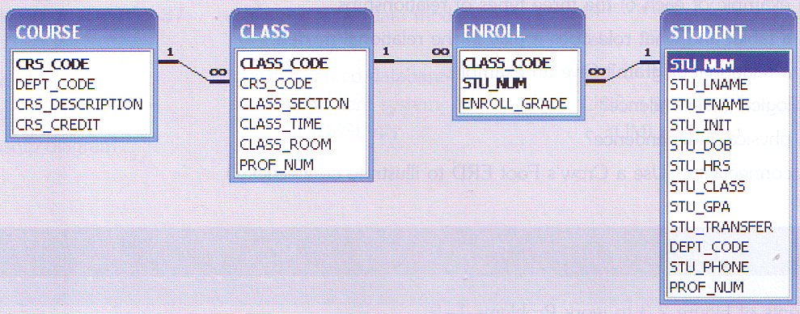

1. Identify each relationship type and write all of the business rules.
2. Create the basic Crow’s Foot ERD for Tiny College.
3. Create the network model that reflects the entities and relationships you identified in the relational diagram.

## Question 5

The following is a brief summary of business rules for the ROBCOR cinema:

A cinema can play many movies. Each movie can be played at many cinemas. The date and time of a movie played at a particular cinema must be recorded. The attributes for movie are Movie ID, Title, Actors, and Category. The attributes for cinema are Cinema Code, and Cinema Name. Each ticket is referred to only one movie, and each movie can issue many tickets. The attributes for ticket are Ticket No, Price, and Seat No. Each ticket may or may not be reserved by an audience, but each audience can reserve many tickets. The attributes for audience are IC, Name, and Contact No.

1. Draw an initial ERD
2. Draw a revised ERD to resolve any many to many relationship
3. Provide a list of attributes for each entity. In your listing, indicate the primary keys (PK), any foreign keys (FK1, FK2)

## Question 6

Consider the following business rules for a newly developed housing property in a well-known local tourism industry:

A buyer can purchase many condominium units. A unit can be owned by many shared owners. The attributes of buyer are B_Name, B_NRIC, B_Address, B_Phone and B_Email. The Date_of_Purchase of a particular unit must be recorded. The attributes of unit are Unit_No, Floor_Level, Sqr_Feet and No_of_Room.

A condominium unit has many rooms. Each room is attached in a unit with a unique Room_No and Room_Type. A room may have zero or many tenants, but each tenant can rent only one room. The attributes for tenant are T_NRIC, T_Name and T_Phone.

Using a Crow’s Foot notation, draw an Entity Relationship Diagram (ERD) for the above scenario. Resolve many-to-many relationship, if any.